Q1. 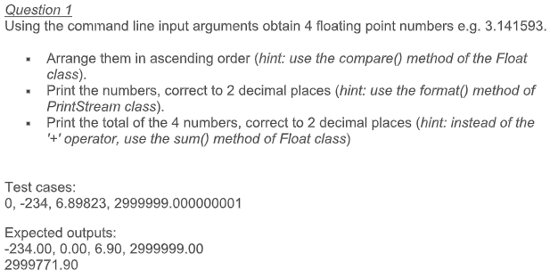

import java.io.PrintStream;

public class FloatPoint {

public static void selectionSort(Double[] arr){

for (int i = 0; i < 4 - 1; i++){

int index = i;

for (int j = i + 1; j < 4; j++){

if (Double.compare(arr[j], arr[index]) < 0){

index = j;//searching for lowest index

}

}

double smallerNumber = arr[index];

arr[index] = arr[i];

arr[i] = smallerNumber;

}

}

public static void main(String[] args){

Double[] numbs = new Double[4];

for(int i=0; i<4; i++)

numbs[i] = Double.parseDouble(args[i]);

selectionSort(numbs);

PrintStream ps = new PrintStream(System.out);

for(int i=0; i<4; i++)

ps.format("%.2f ", numbs[i].doubleValue());

ps.format("\n%.2f \n",

Double.sum(Double.sum(numbs[0], numbs[1]),

Double.sum(numbs[2], numbs[3])));

}

}

Q2. 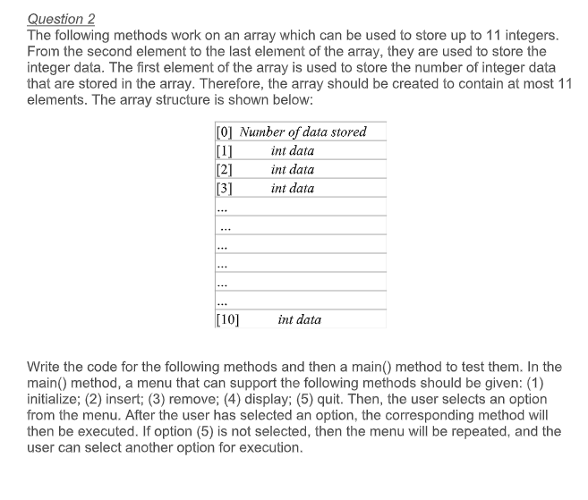

import java.util.Scanner;

public class ArrayMenu {

public static void main(String[] args) {

boolean quit = false;

int[] arr = {0};

Scanner sc = new Scanner(System.in);

while(!quit){

System.out.println("Enter choice number:");

System.out.println("1. Initialize\n2. Insert\n3. Remove");

System.out.print("4. Display\n5. Quit:");

int choice = sc.nextInt();

switch (choice) {

case 1:{

arr = new int[11];

System.out.println("\nArray Initialised\n");

}break;

case 2:{

System.out.print("Enter position:");

int pos = sc.nextInt();

System.out.print("Enter Value:");

int val = sc.nextInt();

System.out.println();

if(arr[pos] == 0)

arr[0] += 1;

arr[pos] = val;

}break;

case 3:{

System.out.print("Enter position to remove:");

int pos = sc.nextInt();

int val = arr[pos];

for(int i = pos+1; i<11; i++)

arr[i-1] = arr[i];

System.out.println("\nRemoved Value: "+val+"\n");

arr[0] -= 1;

}break;

case 4:{

int len = arr[0];

System.out.println("\nElements in the array:");

for(int i=1; i<=len; i++)

System.out.print(arr[i]+" ");

System.out.println("\n");

}break;

case 5:{

System.out.println("\nExiting Application...");

quit = true;

}break;

default:

System.out.println("\nInvalid Choice\n");

}

}

}

}